**The relevance of the blame-game: Is urban carbon-footprint data useful?**

(Ir)relevant responsibility: Do urban consumption accounts produce useful information for policymakers?

Responsibility or Relevance? Two directions for urban carbon footprint accounts

Measuring ‘Bites’ and Counting ‘Bulges’: The Effect of Endogenising Capital for Determining Responsibility and Relevance in Urban I-O Accounts

Joel Millward-Hopkins* and Andrew Sudmant,

Sustainability Research Institute,

University of Leeds,

*[j.t.millward-hopkins@leeds.ac.uk](mailto:j.t.millward-hopkins@leeds.ac.uk)

**Abstract**

The past decades have seen increasing amounts of attention being given to the role of cities in mitigating carbon emissions. As part of this, there has been a rise of urban consumption-based accounting to produce ‘carbon footprints’, which contrast with traditional production-based accounts. Methods for producing urban carbon footprints are advancing, but they remain highly data- and time-intensive, and continue to embody a (well-known) conceptual error regarding how emissions from *capital* (building of houses and public and productive infrastructures) are allocated. Focus is turning toward investigating how cities can most effectively reduce their carbon footprints and this presents questions regarding the practical value of carbon footprint accounts. Here we discuss the interaction between (consumer) *responsibility* and (practical) *relevance* for urban carbon accounting, and the fallacy of assuming (uncritically) that the latter flows from the former. Regarding *capital*, we conclude that the two distinct ways of treating this in consumption-based accounts have significant implications for the trade-off between ‘responsibility’ and ‘relevance’, particularly for cities (relative to nations). Provided capital is treated appropriately, for the purposes of responsibility bespoke urban models are potentially unnecessary; downscaled national carbon footprints would generally suffice. Currently, however, given the capacities of local governments, urban carbon footprints appear most accurate where they may be least useful and vice versa. Reflecting upon these various observations, we question the value of ‘the city’ as a subnational unit of analysis for carbon footprinting, suggesting that while this is appropriate in in some cases (government consumption and infrastructure formation) it makes little sense in others (household consumption).

**Keywords**

Climate change, Cities, Carbon footprint, Input-output, Carbon accounting, Climate policy

**1.    Introduction**

Over the past two decades, increasing importance has been placed upon the role of cities in mitigating climate change, due both to the extent of their carbon emissions and their (perceived) capacity to address them. Activities in cities are now responsible for the majority of global energy use and carbon emissions [1], a fact unsurprising given that, since 2007, cities have become home to the majority of the human population. Frequently, city governments are better placed and more flexible than higher-level governments for dealing with (at least) some urban mitigation challenges [2].

The degree to which cities and their populations are considered accountable for carbon emissions largely depends, however, upon the specific accounting framework employed and the associated value judgements of the researcher, policy-maker, etc. [3]. Carbon emissions analysis is largely focused upon two frameworks (although others exist [4]), namely *production-based* (PB) and *consumption-based* (CB) accounting, the differences between which are now widely discussed in climate policy literature from technical, practical and ethical perspectives [5]. Urban PB accounts capture all the emissions emitted from within cities’ borders (i.e. *scope 1* emissions) as well as those emissions involved in producing imported electricity or heat (i.e. *scope 2* emissions; [6]). In contrast, urban CB accounts capture all the emissions involved in producing goods and services consumed by the households and government of a city [7].

PB accounts have some obvious advantages, among which are their (relative) simplicity, and greater familiarity to policy-makers and members of the public alike due to their traditional use in national-level accounting and international negotiations. But they have various shortcomings too. For urban areas they can be dominated by point-source emissions (for example, from cement or steel plants), which overshadow emissions from activities the city may influence [8]. And as they exclude supply chain emissions related to the consumption of city populations, they can give the impression that many of the world’s wealthiest cities make a relatively small contribution to climate change [9], leading also to potential mitigation opportunities being overlooked [10].

CB accounts are far more complex and data intensive to produce. However, capturing the full carbon impacts of cities’ consumption has the potential to allocate carbon emissions in a more revealing way than conventional PB accounts, as cities’ inherently high population densities ensure they are mass importers of goods, energy and materials – normally net importers [11]. These impacts can only be understood from a consumption-perspective. In this process, however, a concept of *consumer responsibility* is implicitly assumed, which follows the intuition that the residents of a city should be responsible for the emissions involved in producing the goods and services they consume and derive benefits from, even if the emissions occur elsewhere [12]. (Note, discussions of ‘responsibility’ are highly contentious, as we discuss further below).

City-scale consumption-based carbon accounting has received significant attention in recent years. National CB accounting methods using Environmentally Extended Input-Output (IO) modelling are now well established [13], but city-scale models remain more difficult to compile, with levels of detail ranging from simple downscaling of national or regional data [11] to more bespoke urban models [14-16]. The number of urban IO studies undertaken has grown rapidly and they have unearthed various findings. Perhaps the most important being that, when major industrial point sources are not present, CB accounts tend to significantly exceed PB accounts. This is especially the case in industrialised countries, but also in rapidly growing, high-consuming cities in industrialising nations [9, 11, 17]. Urban CB accounts can be a factor of ~2 larger than PB emissions and larger still when measuring all greenhouse gases due to agriculture (cities rarely produce substantial fractions of their food) [10].

Within and beyond academia, CB accounts are increasingly being presented as a logical step for urban areas looking to lead on climate change. This is seen, for example, in the growing number of urban areas commissioning CB accounts and making commitments to reduce their CB emissions [17] and in research that present urban CB accounts as being useful for informing urban climate action plans [9, 10][1]. Amidst these developments, an assumption is often made that, in the process of more accurately representing the emissions *responsibility* of cities, CB accounts also provide information of *relevance* – information on emissions sources that it is feasible and practical for a city to target with mitigation strategies. Put another way, it is often assumed that city governments ability to mitigate production and consumption emissions is comparably large [11]. While this assumption is by no means made by all authors or policymakers, this paper argues that is it nonetheless a trend sufficiently common and counterproductive to warrant examination.

Much discussion has taken place regarding the trade-offs between PB and CB accounting [5, 18, 19], but for cities there are additional considerations not found in debates focused on national-level accounts. We thus interrogate the value of urban CB accounts for urban policymaking, with respect to current methods and likely future developments, with particular focus upon three questions:

1. How does the treatment of capital (i.e. *infrastructure*) within IO models impact upon the value of the outputs for the (sometimes conflicting) purposes of responsibly and relevance?
2. How valuable is the information provided by bespoke urban CB accounts compared to that obtained via a simple downscaling of national CB accounts?
3. When is ‘the city’ a valuable subnational unit of analysis for subnational carbon-footprint accounting?

We discuss these questions in the results and discussion below, after first providing an overview of urban IO models in Section 2. Details on the data and analysis we use to support our argument are included in the Supplementary Materials.

**2.    Urban carbon footprint models**

2.1. IO models

Input output models capture all the economic transactions occurring between the various industries and final consumers of an economy. Multi-regional models include international trade. Environmentally extended IO models for carbon emissions take the source emissions of each industry and reallocate these to final consumers by attaching them to the financial transactions occurring in between industries along supply chains. These extended models allow matrices to be produced that indicate the carbon intensity of a unit of expenditure (or *final demand*) on any goods and services in an economy, and where the emissions occur in terms of source industry and world region. These are then combined with final demand data for a region (nation, city, etc.) to obtain the carbon footprint. The mathematics of the approach are explained well in various other papers [7, 20, 21].

Final demand is generally divided into *household*, *government* and *capital* (and *other*, but this is typically negligible). The split between these various sources varies significantly between geographic regions, and relates to regions’ development trajectories. Household expenditure typically accounts for ~40-80% of a nation’s emissions [22], followed by capital ranging from ~15% to 55% [23] and government at 5%-20% [17]. China lies at the top end of the data for capital-related emissions.

A crucial point for our later discussion relates to capital expenditure. Although capital – e.g. houses, public infrastructures, factories – is typically considered a distinct final demand category in IO models, much of it actually forms an input into other final demand categories. For example, in current IO models, the emissions from energy use in a Chinese steel factory that provides steel to Japanese car manufactures that sell vehicles to UK residents, will contribute towards the UK household carbon footprint. However, the emissions from *building* the Chinese steel factory would be allocated to the Chinese carbon footprint and recorded under their *capital* final demand. It is possible to endogenise capital such that all related emissions are allocated to the relevant goods and services purchased by households or governments, and researchers have recently succeeded in modifying national CB accounts in this way [24]. But there remains a temporal issue, e.g. how the emissions of the steel factory are spread over time, which may involve forecasting steel output. Capital is therefore a crucial issue that we return to below.

2.2. The C40 cities

To support our arguments below, we draw heavily upon carbon footprint data from 96 cities in the C40 Cities network; a consortium of global cities attempting to reduce their climate change impacts. These cities are diverse in character and spread across all continents bar Antarctica. Collectively, they account for ~7% of the global population and, from a consumption-based perspective, ~10% of all global greenhouse gas emissions. We describe the data further in the supplementary materials, but the crucial methodological points to bear in mind for the discussion below are that (i) a consistent model is used for each city, (ii) the model takes into account city-specific industrial structure, household expenditure and trade flows between each city and the rest-of-nation and rest-of-world, and (iii) while household footprints are bespoke to each city, government and capital footprints remain estimated from downscaled national per capita data.

**3.    Results and discussion**

*3.1. Urban consumption-accounting for ‘responsibility’*

‘Responsibility’ is a morally loaded word, and methods for assigning carbon emissions to regions or populations have been discussed for decades and are inherently laden with value judgements [3]. *Consumer responsibility* and *producer responsibility* occupy two ends of a possible spectrum of attributing emissions responsibility, with *shared responsibility* taking a middle way [*ibid*]. Consumer and producer responsibility line up, of course, with consumption- and production-based carbon accounting, respectively.

**Accounting for capital**

To build a complete picture of the carbon footprint of a city (or any other unit of analysis), it is necessary to capture the emissions involved in producing the capital – factories, offices, roads, airports and other productive infrastructures – required to produce and distribute goods and services. This is done by *endogenising* capital into household consumption, however, this approach is currently not standard practice in urban CB accounting. In Figure 1 we illustrate the effect of endogenising capital for cities that are net importers of emissions (i.e. *consumer cities*) and net exporters (*producer cities*). Here we use London (UK) and Qingdao (China) as examples of producer and consumer cities, respectively. However, we must emphasise that Figure 1 is *illustrative*, not precise; various simplified calculations were made due to limitations of the present model and data availability issues.

The illustrations on the left show conceptually correct CB accounts with capital endogenised into household and government consumption, and those on the right show current methods with capital recorded separately. For London, without capital endogenised, the ratio CB/PB emissions is ~2, while for Qingdao the same ratio is <1. Exports are a much larger fraction of Quindao’s PB emissions (~95%) than London’s (~60%), while capital represents a larger fraction of Qingdao’s CB emissions (~45%) than London’s (~15%). In the right hand figures, the ‘bites’ taken out of the household and government footprints are those emissions that are missing from current CB accounts due to capital not being endogenised. It is not possible to tell from the C40 data how big these missing ‘bites’ are, however, data from other sources [25] suggests that emissions embodied in Chinese exports of goods could increase by ~35% if capital were endogenised (note, however, that more recent work suggests this could be at the upper end of what’s reasonable [24]). On the other hand, when capital is not endogenised, cities’ carbon footprints capture emissions that are involved in producing exports, rather than serving their own residents’ consumption. These are represented by the portion of capital emissions in the right-hand figures that ‘bulge out’ and thus do not overlap with household and government CB emissions. For Qingdao, this ‘bulging out’ is more significant than for London, mirroring the larger fraction of PB emissions in the former that are associated with exports.

A rough estimate of capital-related emissions can thus be made. For London, endogenising capital would first reduce CB emissions by 15% (the proportion currently due to capital) and then the remainder would increase by up to 35% due to endogenising capital into household and government consumption. Here, 35% is based upon data referenced above [25]; it gives a rough estimate of the size of the ‘missing bites’ from the household and government emissions. Overall, the effect of endogenising capital for London would be to increase CB emissions by 15%, while the same calculation for Qingdao would reduce CB emissions by 25%. Endogenising capital can thus significantly amplify the differences between CB emissions for typical *consumer* and *producer* cities, thus having significant implications for a consumer-responsibility perspective.

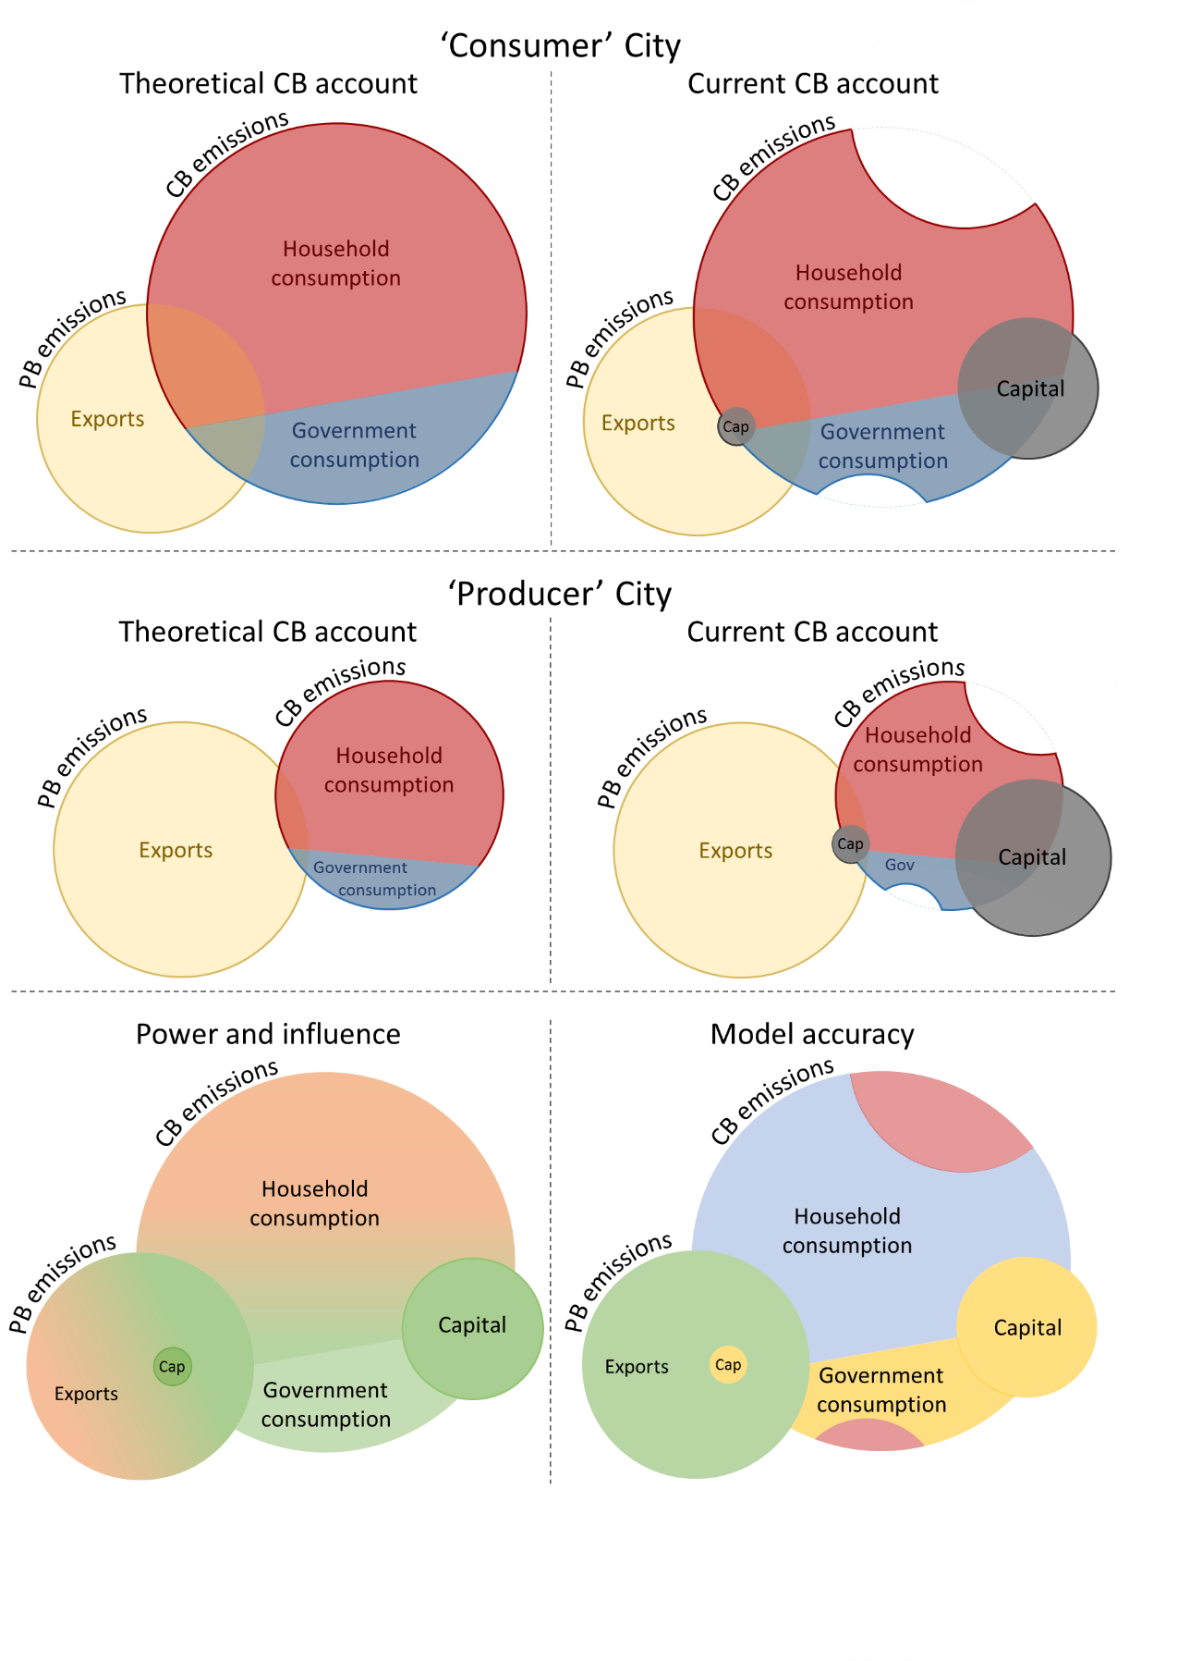

**Figure 1:** Sketches of production- and consumption-based emissions for illustrative *producer* and *consumer* cities (London and Qingdao), with theoretically consistent accounts on the left (capital endogenised) and current IO models on the right (capital separate). For capital, the large circles represent material supply chains and small circles the onsite emissions of construction sites (assumed here to be an order of magnitude smaller). Yellow circles represent PB emissions and thus enclose *all scope 1 and 2* emissions. Household and government consumption together (plus capital when not endogenised) represents CB emissions. The portion of CB emissions that do not overlap with the yellow circles represent *scope 3* emissions, while the areas of the yellow circles that do not overlap with CB emissions represent scope 1 and 2 emissions involved in producing *exports*.

**Model complexity**

While endogenising capital in urban IO models appears necessary to reduce bias in urban carbon footprints, is it useful to ask how complex a model is needed to produce data sufficient for estimating consumer responsibility. Are bespoke urban models necessary, or would downscaled national models be adequate? Producing city-level carbon footprints is a highly time and data intensive task, yet the consistent message from the IPCC is that emissions must peak within a handful of years from now for there to be a reasonable chance of avoiding dangerous levels of climate change. To this end, simple, widely applicable models that local governments may draw upon with minimal effort would be hugely advantageous. Whole literatures exist devoted to the value of simple, heuristic models in decision making [26, 27], and similar lessons may apply in the context of city carbon footprints, where some argue excessively detailed accounting has already crept in [8].

So as not to distract from the overarching narrative, we describe our analysis of national- vs. bespoke city-level data in the supplementary materials (SMs), summarising only our most important findings here. In short, national-level carbon footprint data with a simple downscaling appears to have the potential to provide remarkably accurate estimates of city-level carbon footprints. For the 96 C40 cities, over 92% of the variation in carbon footprints can be explained using the national CB emissions alone. When we dig deeper and split the carbon footprints into 17 components, only the emissions from food and drink and direct emissions from households’ vehicles deviate substantially from national per capita values while also contributing significantly to cities’ footprints. This hints at a feasibility to develop an accurate, yet simple model to estimate city-level carbon footprints by downscaling national data and making a simple correction for food-related emissions (perhaps using an indicator of meat consumption) and incorporating scope 1 data for household transport.

The main limitation behind this conclusion is that while the C40 model is city-specific for household carbon footprints, it remains based upon downscaled national data for government and capital footprints (as many urban IO models do). Therefore we cannot tell how much the cities’ government and capital emissions may differ from national averages. However, this is less of a shortcoming as it first appears. If capital were endogenised then it would be embedded in the household footprints and, consequently, would have the same (relatively high) correlations with national data. Further, regarding government emissions, allocating national values equally across the population is arguably a reasonable approach if the intention is to assign consumer-responsibility, given (almost) all residents of a nation benefit from things like national transport networks and electricity infrastructure.

In summary, it appears that national data could be sufficient for estimating city-level carbon footprints intended to assign consumer responsibility. But if capital is not endogenised, bias can be introduced that leads to underestimates of the carbon footprints of high-consuming cities and overestimates for industrial cities with high exports.

*3.2. Urban consumption-accounting for ‘relevance’*

**Where do cities have influence?**

The obvious question to now ask is to what degree emissions accounts intended to represent consumer-responsibility are useful for informing feasible and effective city-scale mitigation strategies. In other words, how ‘relevant’ are these carbon footprints accounts to city governments, given governments’ capacities to influence local activities. Viewed from the perspectives of both production and consumption, the potential role of cities in reducing emissions appears unclear, partly as the research is young [28], partly as insufficient time has passed for the effectiveness of experimental initiatives to be understood, but perhaps largely as the huge diversity of cities leads to an equally diverse set of answers [29].

Nonetheless, some broad statements can be made, which we visualise in Figure 4 (left). Regarding scope 1 and 2 emissions, cities may have significant influence over building energy use and transport emissions via familiar strategies such as low-carbon building standards, development of public transport networks, implementation of car free or clean air zones, etc. [30]. When it comes to the emissions of large industrial facilities, however, local powers may be overshadowed by national regulations [31]. Similarly, national actors can pass regulations around product lifespans; place taxes on the consumption of specific goods and services; incentivise reductions in meat consumption [34] or air travel [35, 36]; and implement rules around the export and import of goods and services [5, 32], all of which may make them more effective at addressing household consumption and scope 3 emissions than urban policymakers [31, 33]. This makes household carbon footprint data with capital endogenised more relevant at the national-level than the city-level.

That said, cities may have significant influence where scope 3 emissions follow directly from building and transport activities, e.g., emissions embodied in provision of fuels or vehicle production. And numerous indirect strategies could be developed to target other types of consumption; through support for repair cafes and second-hand stores or, more generally, encouraging smaller houses, which may encourage less accumulation of ‘stuff’ (broadly defined). But such indirect strategies are potentially of limited effectiveness and, further, harder methods of control may be politically infeasible[2]. More positively, cities can of course decide to make their own consumption low-carbon through green public procurement. And via building and planning regulations, cities may also have significant power over the embodied emissions in constructing local infrastructures – i.e. the emissions from *capital* in current IO models, including public (roads, hospitals, schools) and private (factories, commercial buildings, etc.) infrastructures [30].

**Relevance vs. model complexity**

If carbon accounting can offer higher-detail regarding sources of emissions that urban governments have power and influence over, it can support better informed strategies. However, when considering the areas of cities’ power and influence discussed above alongside the accuracy of current urban carbon accounts, there appears almost a precise mismatch. Current accounts appear most accurate where they may be least useful to city policy makers, and least accurate where they may be most useful.

Figure 4 illustrates this, with the right figure showing (qualitatively) areas of high-to-low accuracy in urban carbon accounts. Scope 1 & 2 emissions tend to be accounted for most accurately via established data collection systems. For scope 3 emissions, urban IO models tend to devote most intellectual effort towards determining the carbon footprint of household emissions; where local governments may have least influence (note again, however, that with capital endogenised a significant fraction of these are completely unknown; the red ‘bites’ in Fig 4 right). In contrast, scope 3 data for government activities and capital formation – where local governments may have most influence – are often downscaled from national data on a per-capita basis, so do not capture specific local activities.

Household carbon footprint data does of course have some relevance for urban mitigation strategies, even if local government powers are limited. Again, however, it is likely that downscaled national models provide sufficiently accurate information. This is not just because national-level carbon footprint data has the potential to provide good estimates of city-level carbon footprints, as highlighted in the previous section. Our results also show that when footprints are split into 17 components, the relative importance of these remains highly similar at national- and city-levels across the C40 cities. The most important contributors to national-level carbon footprints tend to be the most important at the city-scale and vice versa. And when the 17 components are ranked from largest to smallest, the ranking of each source at national- and city-levels tend to be the same or within one or two places. It is thus likely that an urban carbon footprint mitigation strategy would look highly similar whether informed by a downscaled national model or a bespoke city CB model. Details supporting this claim are provided in the supplementary materials.

**The relevance of capital accounts**

This discussion leads to another important point regarding capital. When the intention is to illustrate consumer-responsibility, correcting current IO models by endogenising capital is necessary to avoid bias. But when the intention is to develop estimates of emissions most relevant to cities this correction would be counterproductive: it would assign emissions potentially very amenable to cities’ control to the carbon accounts of other regions by embodying them in exports. In London, for example, if capital is not endogenised, the emissions embodied in the steel and concrete of a high-rise building constructed for financial and insurance services will be recorded under London’s carbon footprint, even if 99% of those services are provided to consumers in other cities and countries. These emissions could be highly relevant to local government in London if they have the ability to grant planning permission only to buildings meeting certain standards for embodied environmental impacts. In cities like Quindao, which have substantial levels of exports and capital-related emissions, such issues may be yet more significant.

For urban IO accounting to be most relevant for cities it should thus retain a separate capital account, as in current models. But this would only be helpful if locally specific activities were captured, rather than downscaled national data being used as in current practice. A crucial point here is that a large share of the emissions captured in capital accounts do not fit into the definitions of either scope 1, 2 or 3 emissions. In the hypothetical financial and insurance services building above, the carbon emitted when producing the steel and concrete are scope 1 & 2 in the locality where the industrial facilities are located, scope 3 where the services are consumed, but undefined in London where they form only an intermediate input to service production. The carbon account that may prove most relevant to city governments is thus neither strictly production- nor consumption-based, but rather a combination of both combined with the capture of certain intermediate inputs. The result is something with similarities to *community infrastructure footprints* [4].

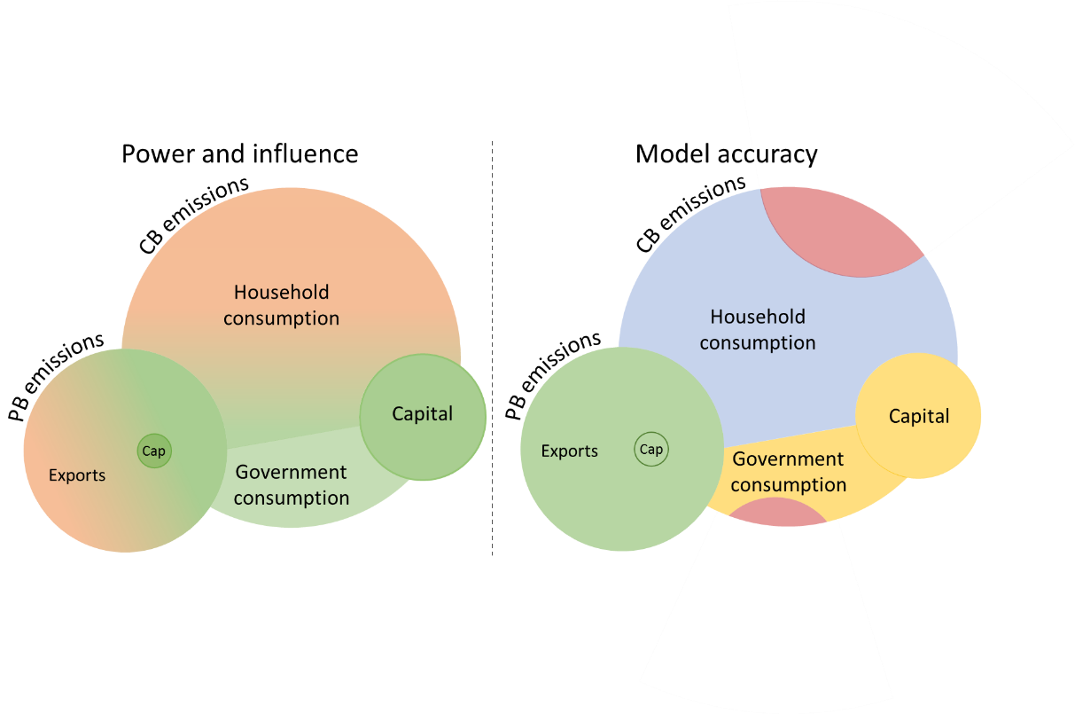

**Figure 4:** Sketches of production- and consumption-based emissions for an illustrative *consumer* city (London) as in Figure 1, but now with a rough indication of the potential power and influence of cities (green = high, orange = low), and the level of accuracy of carbon footprint data (highest-to-lowest: green-blue-yellow-red). Note that source [31] is drawn upon heavily in producing the left figure.

**4.    Conclusions**

The discussion above has attempted to highlight various trade-offs between carbon accounting for consumer responsibility and practical policy relevance in the context of urban carbon accounting. That trade-offs – and synergies – exist between different carbon accounting methods is of course well-known. In the current work, we have attempted to extend these debates to consider the specific trade-offs inherent to city-scale accounting and, relatedly, the trade-offs that occur within consumption-based accounting itself due to necessary assumptions regarding the allocation of capital. Regarding the latter in particular, we have argued that endogenizing capital could significantly improve understanding of consumer responsibility, but this would result in carbon footprint accounts that are less useful to cities given their influence over local activities. This is a critical element of modelling design, but such details can sometimes only be found in the appendixes of citations.

However, this could be considered to be one part of a larger issue. A growing body of work (we offer ourselves as examples here) appears to be approaching questions about urban climate action by first developing urban consumption-based accounts, then considering the potential effectiveness of mitigation options applied to these accounts, and finally uncritically (or at least optimistically) assuming that policies to support these strategies could be developed at the city-level. Due to the way current urban carbon footprint accounts are produced, the focus tends to land disproportionately upon the indirect impacts of household consumption patterns, even though these are perhaps where local governments have least influence.

Indeed, this calls into question the value of the city as a unit of analysis for subnational carbon footprint accounting of household consumption. A key finding of carbon footprint studies is that income is a major driver of carbon footprints [37], while factors such as population density may have surprisingly little influence [38-41]. But differences in average household income between wealthy and poorer cities within a country are generally much smaller than differences between the upper and lower ends of the national population’s income distribution. Within the UK, for example, the average income in London is barely twice that of low-income cities such as Bradford[3]. But nationally the income of the richest 10% of households is approximately ten times that of the poorest 10%. A similarly large inequality of income can be seen within cities themselves, such as in London. Although variations in average income between cities may be more significant for industrialising countries like China and India, these are still overshadowed by broader income inequalities[4].

In this sense, taking the city as a unit of analysis for carbon footprint studies does not follow neatly from perhaps the key finding of consumption-based emissions research. Further, once we as researchers or policy makers (or, of course, citizens) have in front of us data describing ‘the average carbon footprint of a city’ it is all too easy to see everything in terms of an ‘average’ resident of London or Kolkata or Tokyo. This leaves the huge inequalities in carbon emissions that exists between the richest and poorest residents within such cities obscured [33].

It could be argued, therefore, that when moving from national to subnational carbon footprint accounting, different units of analysis are appropriate for different components of the footprint.

For household footprints, using income deciles or similar demographics makes most sense for consumer-responsibility, as variation between people within each decile will likely be much smaller than variations between people within a city. Such an approach could be more relevant as well given how regulations may work: progressively increasing taxes on flying, for example, would be far more likely to be implemented nationally than at the city-level, and would primarily affect higher income groups. One may crudely summarise that city-scale carbon footprint accounting may simply end up partitioning high-income, high-consuming, high-impact consumers into relatively arbitrary geographical units, and then placing their emissions under the remit of local urban governments.

In contrast, however, for government and capital-related carbon footprints it seems sensible to look at city-scale data derived with bespoke city models. In this case, this is where direct influence is likely to exist, and where locally-specific activities may deviate importantly from national trends.

There are of course concerns regarding double counting that arise from these propositions. But if the intention is to develop information of most relevance to city governments, rather than accounts that can be aggregated into some cumulative geographical unit, such concerns are not important. And it should be emphasised that it is still valuable to estimate household carbon footprints for cities. The above discussion suggests only that this information may be of limited relevance for practical action; that it serves mostly as an illustration of responsibility. This is another strong argument for taking a heuristic approach to estimating city-level carbon footprints via national-data.

This may have a further, more subtle advantage, by avoiding what could be called ‘modellers lock-in’. Researchers exploring urban mitigation strategies using existing carbon footprint data are aware that the data they are using is far more accurate in some places (i.e. household expenditure) than others (i.e. infrastructure). They may thus be tempted to build more mitigation options upon the more robust part of the underlying data, even though this may not be where the most effective options exist (note, we speak here from personal experience).

One final point is necessary to discuss. So far we have spoken of ‘responsibility’ while evading the question of what we really mean: do we mean moral responsibility; something softer? Certainly producing carbon footprints for income-deciles rather than cities appears intuitively closer to something that could be assumed to allocate responsibility in a morally defensible way. But this is still easily contended, and debate could slide towards the marginal returns upon well-being above modest consumption-levels [42]; whether high suicide rates in wealthy countries further underline a collective cognitive dissonance around the relationship between consumption and well-being; and philosophical debates regarding the limits (or even existence) of ‘free will’ that are 1000s of years old and to which neuroscience is now offering unsettling answers; or even Biblical parables of *Rich Fools* and their money (how responsible for a foolish act can a fool be?)

More concretely, some will argue that producers have ultimate control over how materials and energy are used to provide goods and services and thus should accept ultimate moral responsibility; others will argue that consumer-demand dictates the activities of producers who adapt to consumers’ needs and wants. In practice the answer likely lies somewhere in the middle and, further, the balance of power between consumers and producers will change for different types of goods and services [43, 44] and within different geopolitical contexts.

The danger, as many have highlighted before, is that a slide too far towards a consumer concept of responsibility will lead to too strong a reliance upon *green consumerism*, which can be provide a partial answer to the challenge of carbon emissions. This criticism of how mitigation is framed is old, and a brazen example of such framing, in the form of a quote from the energy company *E.on*, is reported by Gyberg and Palm: *It's easy to blame the industry and transport as the ones guilty of environmental crime. But who decides what to produce and what to ship to different parts of the world? Isn’t it you as a consumer?* [45]. This is clearly a dangerous path, upon which consumption-based accounting unfortunately sits quite neatly. City-scale carbon accounting would be wise to avoid walking down it as well.

**References**

1. Seto, K.C., et al., *Human Settlements, Infrastructure and Spatial Planning* in *Climate Change 2014: Mitigation of Climate Change. Contribution of Working Group III to the Fifth Assessment Report of the Intergovernmental Panel on Climate Change [Edenhofer, O., R. Pichs-Madruga, Y. Sokona, E. Farahani, S. Kadner, K. Seyboth, A. Adler, I. Baum, S. Brunner, P. Eickemeier, B. Kriemann, J. Savolainen, S. Schlömer, C. von Stechow, T. Zwickel and J.C. Minx (eds.)]*. 2014, Cambridge University Press: Cambridge, UK and New York, USA.

2. Fuhr, H., T. Hickmann, and K. Kern, *The role of cities in multi-level climate governance: local climate policies and the 1.5°C target.* Current Opinion in Environmental Sustainability, 2018. **30**: p. 1-6.

3. Lenzen, M., et al., *Shared producer and consumer responsibility — Theory and practice.* Ecological Economics, 2007. **61**(1): p. 27-42.

4. Chavez, A. and A. Ramaswami, *Articulating a trans-boundary infrastructure supply chain greenhouse gas emission footprint for cities: Mathematical relationships and policy relevance.* Energy Policy, 2013. **54**: p. 376-384.

5. Afionis, S., et al., *Consumption-based carbon accounting: does it have a future?* Wiley Interdisciplinary Reviews: Climate Change, 2017. **8**(1): p. e438-n/a.

6. WRI, C., and ICLEI, *Global Protocol for Community-Scale Greenhouse Gas Emission Inventories (GPC): An accounting and reporting standard for cities*, in [*www.ghgprotocol.org*](www.ghgprotocol.org) *(accessed 6 March 2016)*. 2014, World Resources Institute, C40 Cities Climate Leadership Group, and ICLEI Local Governments for Sustainability.

7. Peters, G.P., *From production-based to consumption-based national emission inventories.* Ecological Economics, 2008. **65**(1): p. 13-23.

8. Erickson, P. and T. Morgenstern, *Fixing greenhouse gas accounting at the city scale.* Carbon Management, 2016. **7**(5-6): p. 313-316.

9. Sudmant, A., et al., *Producer cities and consumer cities: Using production- and consumption-based carbon accounts to guide climate action in China, the UK, and the US.* Journal of Cleaner Production, 2018. **176**: p. 654-662.

10. Millward-Hopkins, J., et al., *Uncovering blind spots in urban carbon management: the role of consumption-based carbon accounting in Bristol, UK.* Regional Environmental Change, 2017. **17**(5): p. 1467-1478.

11. Daniel, M., et al., *Carbon footprints of 13 000 cities.* Environmental Research Letters, 2018. **13**(6): p. 064041.

12. Steininger, K., et al., *Justice and cost effectiveness of consumption-based versus production-based approaches in the case of unilateral climate policies.* Global Environmental Change, 2014. **24**: p. 75-87.

13. Kanemoto, K., D. Moran, and E.G. Hertwich, *Mapping the Carbon Footprint of Nations.* Environmental Science & Technology, 2016. **50**(19): p. 10512-10517.

14. Chen, G., M. Hadjikakou, and T. Wiedmann, *Urban carbon transformations: unravelling spatial and inter-sectoral linkages for key city industries based on multi-region input–output analysis.* Journal of Cleaner Production, 2016.

15. Chen, G., et al., *City Carbon Footprint Networks.* Energies, 2016. **9**(8): p. 602.

16. Wiedmann, T.O., G. Chen, and J. Barrett, *The Concept of City Carbon Maps: A Case Study of Melbourne, Australia.* Journal of Industrial Ecology, 2015: p. n/a-n/a.

17. C40, *Consumption-based GHG emissions of C40 cities*. 2018, C40 Cities, University of Leeds, University of New South Wales, and Arup.

18. Steininger, K.W., et al., *Multiple carbon accounting to support just and effective climate policies.* Nature Climate Change, 2015. **6**: p. 35.

19. Jakob, M., J.C. Steckel, and O. Edenhofer, *Consumption- Versus Production-Based Emission Policies.* Annual Review of Resource Economics, 2014. **6**(1): p. 297-318.

20. Barrett, J., et al., *Consumption-based GHG emission accounting: a UK case study.* Climate Policy, 2013. **13**(4): p. 451-470.

21. Davis, S.J. and K. Caldeira, *Consumption-based accounting of CO2 emissions.* Proceedings of the National Academy of Sciences, 2010. **107**(12): p. 5687-5692.

22. Ivanova, D., et al., *Environmental Impact Assessment of Household Consumption.* Journal of Industrial Ecology, 2016. **20**(3): p. 526-536.

23. Södersten, C.-J., R. Wood, and E.G. Hertwich, *Environmental Impacts of Capital Formation.* Journal of Industrial Ecology, 2018. **22**(1): p. 55-67.

24. Södersten, C.-J.H., R. Wood, and E.G. Hertwich, *Endogenizing Capital in MRIO Models: The Implications for Consumption-Based Accounting.* Environmental Science & Technology, 2018. **52**(22): p. 13250-13259.

25. Minx, J.C., et al., *A “Carbonizing Dragon”: China’s Fast Growing CO2 Emissions Revisited.* Environmental Science & Technology, 2011. **45**(21): p. 9144-9153.

26. Gigerenzer, G. and W. Gaissmaier, *Heuristic Decision Making.* Annual Review of Psychology, 2010. **62**(1): p. 451-482.

27. Dawes, R.M., *The robust beauty of improper linear models in decision making.* American Psychologist, 1979. **34**(7): p. 571-582.

28. Creutzig, F., et al., *Towards demand-side solutions for mitigating climate change.* Nature Climate Change, 2018. **8**(4): p. 260-263.

29. Castán Broto, V. and H. Bulkeley, *A survey of urban climate change experiments in 100 cities.* Global Environmental Change, 2013. **23**(1): p. 92-102.

30. Creutzig, F., et al., *Urban infrastructure choices structure climate solutions.* Nature Climate Change, 2016. **6**: p. 1054.

31. Erickson, P., et al., *Technologies, policies and measures for GHG abatement at the urban scale.* Greenhouse Gas Measurement and Management, 2013. **3**(1-02): p. 37-54.

32. Barrett, J. and K. Scott, *Link between climate change mitigation and resource efficiency: A UK case study.* Global Environmental Change, 2012. **22**(1): p. 299-307.

33. Hoornweg, D., L. Sugar, and C.L.T. Gómez, *Cities and greenhouse gas emissions: moving forward.* Environment and Urbanization, 2011. **23**(1): p. 207-227.

34. Yau, Y.Y., B. Thibodeau, and C. Not, *Impact of cutting meat intake on hidden greenhouse gas emissions in an import-reliant city.* Environmental Research Letters, 2018. **13**(6): p. 064005.

35. Ivanova, D., et al., *Carbon mitigation in domains of high consumer lock-in.* Global Environmental Change, 2018. **52**: p. 117-130.

36. Ottelin, J., J. Heinonen, and S. Junnila, *Greenhouse gas emissions from flying can offset the gain from reduced driving in dense urban areas.* Journal of Transport Geography, 2014. **41**: p. 1-9.

37. Wiedenhofer, D., et al., *Household time use, carbon footprints, and urban form: a review of the potential contributions of everyday living to the 1.5°C climate target.* Current Opinion in Environmental Sustainability, 2018. **30**: p. 7-17.

38. Heinonen, J., R. Kyrö, and S. Junnila, *Dense downtown living more carbon intense due to higher consumption: a case study of Helsinki.* Environmental Research Letters, 2011. **6**(3): p. 034034.

39. Ottelin, J., J. Heinonen, and S. Junnila, *New Energy Efficient Housing Has Reduced Carbon Footprints in Outer but Not in Inner Urban Areas.* Environmental Science & Technology, 2015. **49**(16): p. 9574-9583.

40. Minx, J., et al., *Carbon footprints of cities and other human settlements in the UK.* Environmental Research Letters, 2013. **8**(3): p. 035039.

41. Jones, C. and D.M. Kammen, *Spatial Distribution of U.S. Household Carbon Footprints Reveals Suburbanization Undermines Greenhouse Gas Benefits of Urban Population Density.* Environmental Science & Technology, 2014. **48**(2): p. 895-902.

42. Steinberger, J.K., et al., *Pathways of human development and carbon emissions embodied in trade.* Nature Clim. Change, 2012. **2**(2): p. 81-85.

43. Brooks, A., *Systems of provision: Fast fashion and jeans.* Geoforum, 2015. **63**: p. 36-39.

44. Fine, B., *Towards a Political Economy of Food.* Review of International Political Economy, 1994. **1**(3): p. 519-545.

45. Gyberg, P. and J. Palm, *Influencing households’ energy behaviour—how is this done and on what premises?* Energy Policy, 2009. **37**(7): p. 2807-2813.

1. The authors would like to note that they have cited themselves here as examples of cases where academic literature has uncritically assumed ‘relevance’ follows from ‘responsibility’.
2. In Brighton, for example, one of the most progressive local UK governments’ efforts to implement *Meat free Mondays* across public workers’ cafeterias failed at the first hurdle; that hurdle being outraged refuse workers (see, for example, <https://www.theguardian.com/politics/2011/aug/29/green-party-100-days-brighton>)
3. See UK government statistics, or that of independent groups, e.g. here: <https://www.centreforcities.org/data/>
4. See data from the World Bank (<https://data.worldbank.org/>) and Global Metro Monitor (<https://www.brookings.edu/research/global-metro-monitor-2018/>)